**Department of Electrical and Computer Engineering**

**University of Canterbury**

**ENEL 370:  Electronics 1**

**Assignment 1**

**Alcohol breath sensor**

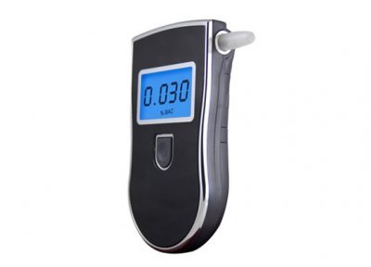

By

Ian Glass (79889718)

Geoff Rutherford (94385584)

28/05/2012

**Table of contents**

1. Abstract
2. Introduction
3. Design description
   1. Sensing module
   2. Thermistor module
   3. Comparator module
   4. Precision peak wave detector
   5. Comparator module with feedback latching
   6. LED reset module
   7. Voltage divider circuit
   8. Timing module
   9. Timing module – BJT method
   10. Voltage regulator
4. Simulation
   1. Sensing module
   2. Comparator module with feedback latching
   3. Voltage divider circuit
   4. Timing module
   5. Voltage regulator
5. Testing
   1. Voltage regulator
   2. RC timing circuit
6. Discussion
   1. Price
   2. Ambient air
   3. Temperature and humidity
   4. RL calibration
   5. Noise analysis
   6. Final circuit
7. Conclusion
8. References

**1.** Abstract

A common problem in modern society is excessive alcohol consumption which can be dangerous to one’s health. With different alcohol concentration of various kinds of alcoholic drinks it can be difficult to know exactly how much alcohol you have consumed. To combat this issue an alcohol breath indicator was designed and built to give someone an indication of how much alcohol has been consumed.

The alcohol breathalyser operates by blowing into a sensor, with three LEDs of green, orange and red colour to indicate if the breath has a low, medium or high concentration of alcohol. The design of the circuit was created by using a circuit simulation software product called “Tina TI". Once the design was complete, it was built on a breadboard and calibrated to display the correct reading for any given alcohol input. Once the circuit was calibrated, the components were removed from the breadboard and soldered onto a veroboard to produce the final product. The final product proved to be very useful and accurate since it displayed the correct reading for any given alcohol concentration input without any problems or errors.

The threshold values required to switch each LED on are 1V, 1.4V and 1.8V for low, medium and high alcohol concentrations respectively. A load resistance of 22kΩ was chosen as this provided the best sensor response when decaying to steady state. An LM324 quad amp package was chosen as the main IC as it provided 4 separate comparator operational amplifiers and was the only comparator package available. The total price of the breath alcohol indicator came to $20.186 which is $4.814 under budget.

**2.** Introduction

Alcohol is a major issue in modern society. The problems associated with excessive alcohol consumption ranges from the health problems it impacts on binge drinkers to people driving over the legal alcohol limit. Due to these problems, an alcohol breath indicator has been designed and built to give someone an indication of whether they have had too much to drink.

Since only an indication is required, the sensor will only output 3 readings of low, medium or high rather than a specific value of alcohol concentration. An output of low is displayed by a green LED when the user blows into the sensor, this indicates to the user that they have consumed little alcohol and their health is at minimal risk. A medium reading is indicated by an orange LED, this tells the user that they have consumed a moderate amount of alcohol and must be careful should they choose to continue consuming alcohol. A high reading is displayed by a red LED, this lets the user know that they have consumed a hazardous amount of alcohol and should refrain from consuming any more. If the user blows into the sensor and none of the indicator LEDs turn on, virtually no alcohol was detected in their breath.

In order for the sensor to operate correctly, it must first have power flowing through it for 2 minutes before it can be used. Once 2 minutes have passed, it may be used for operation. To operate the sensor correctly, the user must first apply the appropriate voltage into the power terminals; they must then flick the switch to the “on” position. Once the switch has been turned on, the circuit will count down from 2 minutes to allow the sensor to heat up to its correct temperature. After 2 minutes, a ‘ready to use’ green LED turn on to indicate to the user that the circuit is ready for use.

The supply voltage that should be used to operate the alcohol sensor appropriately is 9V, however this sensor will operate well between 7V to 25V. Any voltage below 7V can result in an unreliable alcohol display, and any voltage above 25V can causes serious damage to the circuit. The output reading of the sensor must also be as stable as possible. Therefore the alcohol breathalyser could not flicker between different results while the user is exhaling.

To ensure stability the LEDs must hold their respective states for a sufficient enough time for the user to read. As well as being accurate and stable, the total cost of the product including sensor, veroboard, components etc could not exceed $25.

For sensing alcohol vapour, the MQ-3 Gas Sensor was used in this circuit. This is a six terminal device, as seen in figure 1 below. It requires a supply voltage of 5V at its H and B terminal for circuit supply, and heating the sensor. Its opposite H terminal needs to be grounded, and its other B terminal is placed across the load. The MQ3 sensor provides an alcohol to voltage relationship through a change in resistance. The heater increases the temperature of the sensing resistor thereby causing a reaction known in organic chemistry as reduction. This has the effect of increasing its resistivity by reducing the number of charge carriers. When ethanol is incident on the sensor an oxidation reaction occurs and a larger number of charge carries appear. This decreases the overall resistivity of the sensor. By considering the approximated circuit of figure 2, it can be seen that a lower output resistance will result in a larger voltage drop across the load by utilizing the voltage divider rule. Therefore, if a small voltage is detected across the load, a small alcohol concentration must be exhaled into the sensor, and a high voltage reading across the load is the result of a high alcohol concentration.

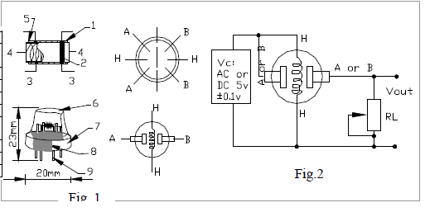

Figure 1

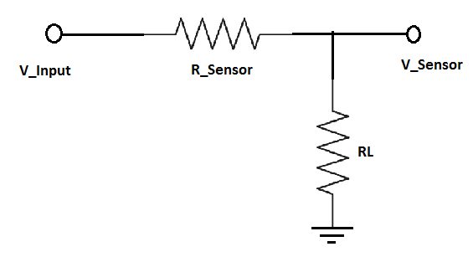

Figure 2

The MC7805 voltage regulator was also used in this circuit to hold a constant voltage. The supply voltage has to be able to swing between 7V up to 25V, therefore the lm7805 Voltage Regulator was used to compensate for this varied supply voltage to feed the circuit with a constant voltage, rather than a varied one. The MC7805 Voltage Regulator works by constantly outputting 5V from its terminals as long as the input is above 6V, any voltage above 6V will be consumed by the Voltage Regulator and it will continue to produce 5V. Two Decoupling Capacitors are also connected to the input and output terminals of the Voltage Regulator to remove any high frequency noise that could be coupled into the circuit.

Diodes [7] [8] were also used in the circuit. A diode is a polarised semi-conductor which is used to allow current to flow in only one direction. If the voltage at the diodes anode terminal is about 0.7 V greater than the voltage at its cathode, then a current that is proportional to the voltage difference will flow. If however the voltage at the cathode exceeds the anode voltage, then current will flow.

The LEDs [8] used for display is just a specialised type of diode. It has the same characteristics as a diode, except that the voltage drop between its 2 terminals is used to generate light. In order for the LED to turn on, it must have a voltage drop of about 2V between its anode and cathode, with a current of about 20mA flowing through it.

**3. Design description**

**3.1 Sensing module**

The MQ3 is the main functional component behind alcohol concentration measurement. A basic voltage divider module was constructed by placing a load resistor (RL) in parallel with the sensor resistor (RS). This divider allowed the relationship between alcohol concentrations and resistances to be measured through voltage dependant circuits by the relationship shown in equation 1.

The circuit sees the potential across the load resistance and as such input voltage can be adjusted through RL. The sensor voltage divider [9] is represented as shown in figure 3.



Figure 3

**3.2 Thermistor**

The MQ3 sensor is sensitive to ambient temperature which can affect the input voltage of the rest of the circuit. Ideally the temperature dependence of the circuit input voltage would need to be removed to achieve an accurate and stable alcohol breathalyser. In effect the ratio of Vout and Vin must be conserved to maintain a constant output for any ambient temperature. Re-arranging eqn.1 reveals equation 2

The ratio of RL and RS must remain constant and therefore their rates of change must also remain constant. Thermistors [5] are resistors which have a resistance gradient dependent on temperature. The relationship of RL and RS with temperature is shown in equation 3

A taylor approximation of RS reveals equation 4

By replacing RL with a thermistor the relationship between Vin and Vout can be maintained within the operating temperature of -10Co to 60Co. The thermistor must have a k value equal to the left hand side of eqn.4. Because this relationship is negatively proportional to temperature an NTC (negative temperature coefficient)[4][6] thermistor is required in parallel. Unfortunately this solution could not be implemented as there were no thermistors available from the electronic store room. The proposed arrangement is as shown in figure 4.



Figure 4

**3.3 Comparator module**

The main functionality behind the circuit requires some way of reading a particular voltage associated with an alcohol concentration and identifying the user that this voltage has been achieved. Comparator operational amplifier circuits [2] do exactly this and as such became a potential solution. Two voltages are inserted into each input pin of the operational amplifier and one of two ‘saturation’ voltages is output. To ensure that the LEDs would remain in either fully active state or a dormant state, the saturation voltages were chosen as 5V and 0V.

The comparator operation amplifier compares two inputs and latches the output to the respective input pin [2]. In the case where the input from the sensor is larger than that of the reference input, the output become high and the LED turns on. Three different comparator networks were implemented to green, yellow and red. A different input reference voltage is set for each comparator network. The circuit diagram behind implementing this circuit is shown in figure 5.

The comparator modules were constructed by using an Op-Amp in its comparator mode for each module. The first comparator had a reference voltage of 0.97V at the Op-Amps inverting input terminal, this voltage would be compared to the input voltage at the non-inverting terminal from the alcohol sensor. If this voltage exceeded 0.97V, then the Op-Amp would switch its output on to about 3.8V. The output terminal is connected to a current limiting resistor and then a grounded green LED. The current limiting resistors were calculated on the final circuit using the forward current of the diodes: Green = 25mA, 120Ω, Yellow = 30mA, 100Ω and Red = 25mA, 120Ω.



Figure 5

**3.4 Voltage divider module**

A simple 3 point voltage divider [9] network was constructed to provide adjustable reference voltages to the comparators. The reference voltage is the minimum input voltage required to trigger a logic ‘on’ or output from the comparator and drive the particular LED. At first standard resistor were implemented, however after some thought and consideration it was decided that adjustable potentiometers would be implemented instead. This was to allow future re-calibration when sensor deterioration became apparent. Using potentiometers reduced component count as each potentiometer acts as an adjustable voltage divider on its own. Because the voltage divisions are dependent on the ratio of resistances rather than the separate resistance of each potentiometer, very large potentiometers were chosen (1MΩ each) to reduce power consumption. The voltage divider module is shown in figure 6.



Figure 6.

**3.5 Precision Peak wave detector**

An issue associated with the MQ3 sensor is the sudden drop in potential, switching LED’s off, possibly before the user has a chance to read them. A simple precision peak wave detector[1] is a circuit which continuously outputs the largest input voltage seen during its run time. The peak detector works by charging a capacitor to the input voltage, this voltage is maintained through feedback into the negative input. If a larger voltage is incident on the positive input, the capacitor receives a larger charge up voltage and feeds that back into the negative pin. The diode prevents back discharge of the capacitor through the amplifier output. This configuration requires an extra single operational amplifier package which is came at a high cost; therefore the precision peak wave detector was omitted as a potential solution to latching. One arrangement of a precision peak wave detector is shown in figure 7.



Figure 7.

**3.6 Comparator module with feedback latching**

In order to maintain a stable and indefinitely continuous LED on state a latching comparator circuit was implemented. By using a feedback resistor from the output to the V+ input a high trigger would force the signal input to be high regardless of a drop in alcohol level across the sensor. A large resistor value was chosen to reduce power consumption and prevent accidental activation of the LED directly from the input signal. One problem encountered in this solution is cross talk between comparator networks as a latch in one would feedback through the signal rail and latches the rest. A diode was implemented to prevent this feedback; however it came at a cost. The diode has an inherent voltage drop across it in forward bias, reducing the apparent input signal seen by the operational amplifier. The feedback latch comparator configuration is shown in figure 8.



Figure 8.

**3.7 LED reset module**

Due to the feedback latching the LED’s remained active regardless of alcohol dissipation within the MQ3. While this is a desired result the ability for a user to freely ‘reset’ the LED states and commence a new test is also desirable. In order to reset the comparator output state the feedback must be grounded; this however required the use of 3 separate switches which incurred a large cost. As the large penalty of using 3 switches outweighed the benefits, a new solution was required. Using a single switch the power input into the operational amplifier package could momentarily be disconnected and cause all the comparator networks to switch to a low output. The implementation of the reset switch is shown in figure 9.



Figure 9.

**3.8 Timing module**

Another criteria required of the breathalyser circuit was a timer circuit to allow the sensor sufficient time to warm up to operating temperature. A comparator circuit similar to the comparator above was used with a voltage divided reference voltage. The positive or logic high input V+ had an RC circuit placed on it to simulate time dependent voltage build up. The voltage can be expressed with equation 5.

Where the circuit switched on when V+ = V-. Large resistors where chosen for the voltage divider and RC circuit to reduce power consumption and a small capacitor was chosen to obtain a charge up time of 90 seconds. The reference voltage for the V- input was around 3.24V with the RC circuit having a time constant of 100 seconds, however when calculating the charge up time versus the measured charge up time, a slight error was found. This error is most likely associated with the characteristic finite resistance of the operational amplifier input. This circuit directly feeds the sensor to restrict use of the circuit until charge up is complete. Unfortunately operational amplifiers have a significant voltage drop across them and the actual output voltage seen by Vin was only 3.71V. The timing circuit is shown in figure 10.



Figure 10.

**3.9 Timing module - BJT solution**

In an attempt to increase the input voltage seen by Vin a BJT was placed on the end of the comparator timing circuit. The idea was to sum the current from VCC and the operational amplifier input to make up the lost voltage from the above solution. Unfortunately an almost insignificant improvement of 0.2V was seen and this slight increase did not outweigh the extra cost in components. This circuit implementation was therefore omitted as a solution. The BJT implementation of the timing module is shown in figure 11.



Figure 11.

**3.10 Voltage Regulator**

The nominal operating voltage of the circuit is 5V however the specification requires that the circuit handle an input voltage between 7V to 9V. Noise and voltage fluctuations due to battery voltage drop are two other considerations needed to ensure proper operation of the circuit. To minimise these issues an MC7805 was implemented with input and output decoupling capacitors. The MC7805 can receive an input voltage ranging between 5V to 18V converting its input to an output of 5V ± 0.2V. This makes it perfect for achieving the design criteria. A typical setup for the MC7805 voltage regulator circuit is shown in fig12.

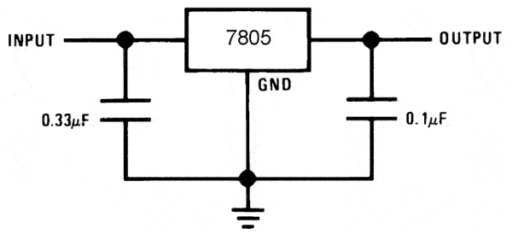

Figure 12.

**4. Simulation (power consumption)**

**4.1 Sensing module**

Simulations performed on the sensor reveal that an increase in resistance does indeed decrease the voltage drop across RL and in effect the voltage seen by the comparator pins. Maintaining a constant input voltage and varying the sensor resistance produces figure 13.

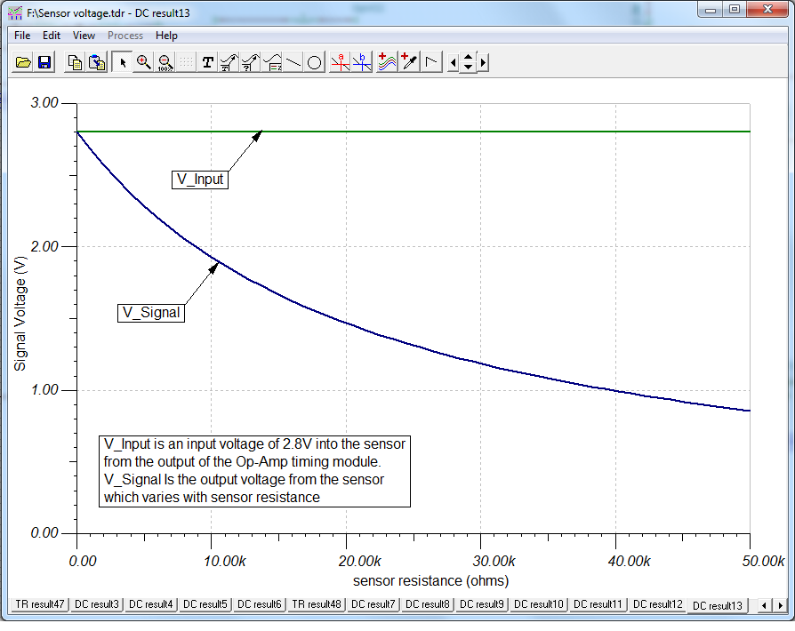

Figure 13.

**4.2 Comparator module with feedback latching**

Figure 14 shows the simulation of the feedback latch comparator network. It is shown that each comparator network latches to high indefinitely once the input voltage is larger than the respective reference voltage. Once latched, only complete disconnection from the power supply can trigger a low comparator output.

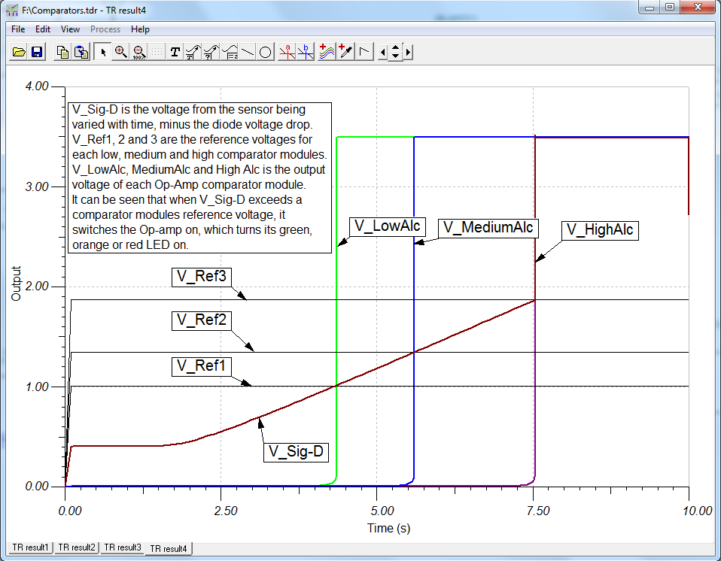

Figure 14.

**4.3 Voltage divider module**

Figure 15 reveals consistency with practical TINA simulations and theory when constructing voltage divider networks. The voltage at each node is reduced by a ratio of the collective impedance seen by the node in each direction. The reference voltages are shown to be stable once initial transients settle.

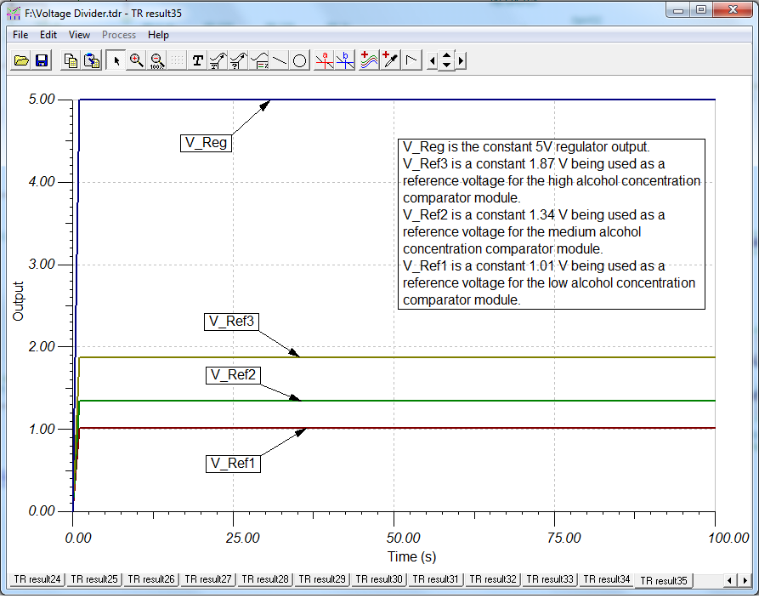

Figure 15.

**4.4 Timing module**

Figure 16 shows the capacitive charge up of the timing module. The dark blue curve is the voltage across the capacitor, the green line is the regulator voltage, the yellow line is the input reference into the timing module comparator (this is the voltage the capacitor must reach to trigger the comparator) and the red line is the comparator output. From this simulation it is clear that feeding an RC network into a comparator works for a timing circuit and the output becomes high when desired.

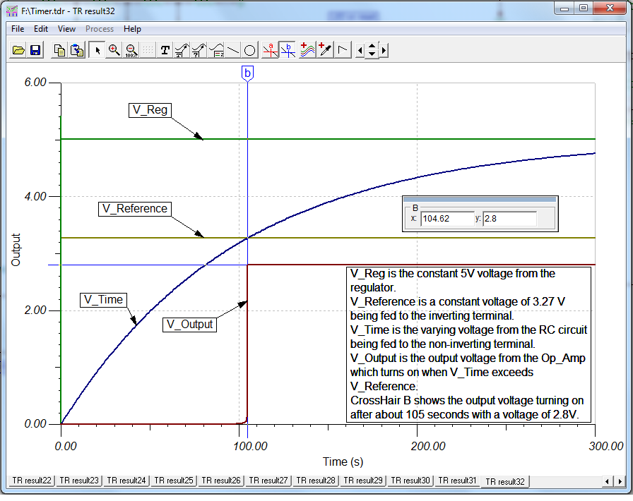

Figure 16.

**4.5 Regulator**

Figure 17 shows the response of the voltage regulator with a varying input. Close analysis reveals that a minimum input voltage of 6.52V is required to obtain a 5V output. This is consistent with theory and shows that the regulator will operate within the required input voltage.

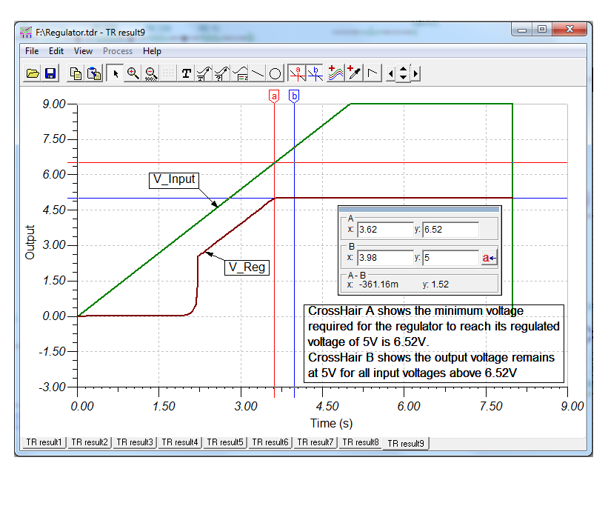

Figure 17.

**5. Testing**

**5.1 Voltage regulator**

Figure 18 shows the actual response of the voltage regulator measured on oscilloscope with a varying voltage. The input voltage was varied between 0 and 10V and within 7V to 9V the regulator maintained a 5V output. This fortifies the simulation result that the regulator will maintain the required 5V output for the 7V to 9V range of input voltages.

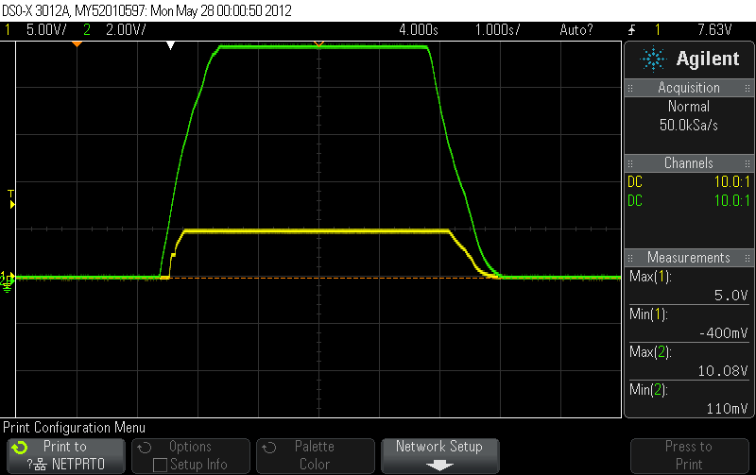

Figure 18.

**5.2 RC timing circuit and timing comparator module**

Figure 19 and 20 shows the RC network charging up from start-up. The green curve is the capacitor voltage and the yellow line is the reference voltage. The intersect of the two curves in figure 19 is where the circuit becomes active and the sensor is ready for use. Close analysis shows that the charge up time is around 100 seconds which allows sufficient time for the sensor to warm up. Figure 20 shows the capacitor charge up with the comparator output state which confirms that above.

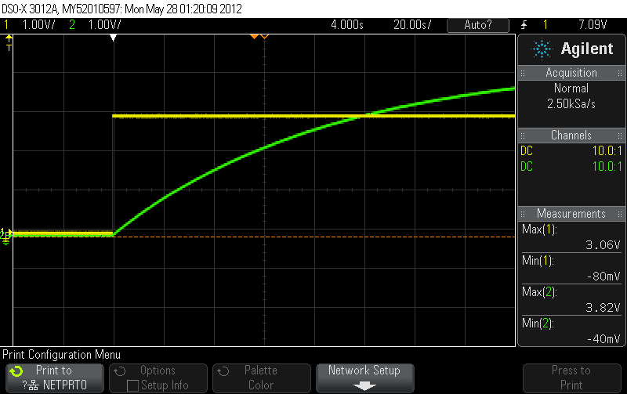

Figure 19.

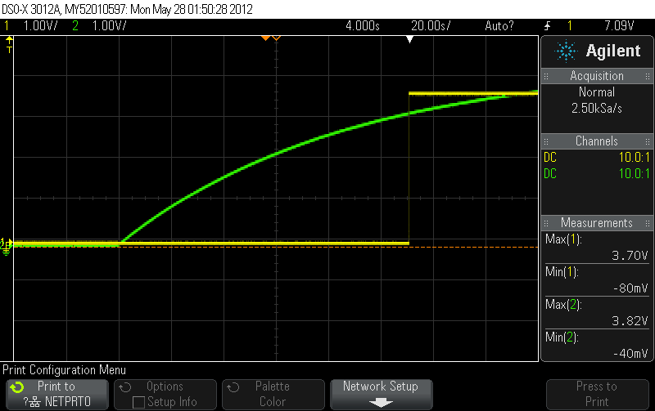

Figure 20.

Figure 21 shows the capacitive discharge of voltage across the sensor after a high alcohol concentration has been applied. The first low step is the settle voltage or warmed up voltage of around 500mV. The next increment is the drastic increase due to alcohol applied. The downward slope models the capacitive discharge and contrasts the waiting time required between successive tests. The slight dip during the discharge shows the effect of pushing the reset switch during discharge. The most prominent feature of this curve is the residual alcohol left within the tube that must be dissipated before operating again. Eventually the output voltage of the sensor will decay back to a steady 500mV.

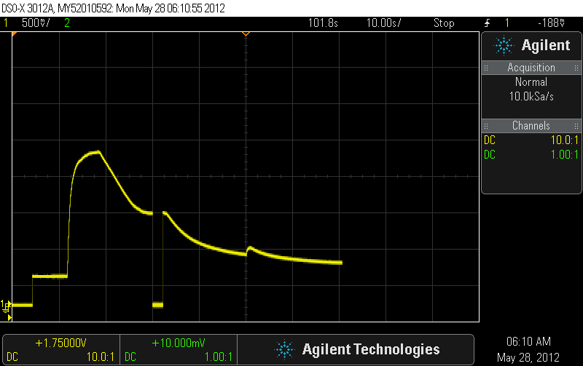

**6. Discussion**

**6.1 Pricing**

|  |  |
| --- | --- |
| Component | Cost ($) |
| LM324 | 0.85 |
| MC7805 | 1.00 |
| Resistors * 11 | 0.55 |
| 1MΩ potentiometers * 3 | 5.1 |
| Pins * 14 | 0.7 |
| 1N4004 | 0.3 |
| IC socket | 0.15 |
| Header | 0.15 |
| Wire | 0.51 |
| Vero-board (2.8 * 1.8 inch) | 3.276 |
| 100 uF 65V Capacitor | 0.3 |
| 10 uF 65V capacitor | 0.6 |
| L-53HD | 0.2 |
| L-53YD | 0.25 |
| L-53GD | 0.25 |
| Switch | 1 |

Total = $15.186 + $5(for sensor) = $20.186

This is under the budget designated for the breath alcohol indicator.

**6.2 Ambient air**

Due to interfering effects of ambient air reducing apparent alcohol concentrations a method for isolation was required. At first a simple piece of plastic tubing was attached to the sensor, however this retained a large amount of the sensor temperature, humidity and above all the apparent concentration of alcohol. This greatly increased the voltage settle time to drop below the low alcohol threshold reading and take a second reading. This problem was overcome by creating large incisions into both sides of the tubing to allow residual alcohol and temperature to escape quickly.

**6.3 Temperature and humidity**

In order to get an accurate idea of real world influence on voltage fluctuation due to temperature change and humidity change, identical measurements were conducted in different rooms with noticeably different conditions. It was found that although temperature dependence does exist within the MQ3 the difference in input voltages was generally no larger than 0.2V and as such temperature and humidity has a very limited effect on the operation of the breath alcohol indicator.

**6.4 RL calibration**

The value for RL changed many times during development to accommodate changes while maintaining useful voltage inputs. The RL values used when testing different implementations ranged 5kΩ to 470kΩ. It was seen that larger values of RL reduced the dynamic range of voltage input values and as a result made it very difficult to construct a stable circuit. Another large down fall to using a large RL was an increased Vsig settling time. When a value of 10kΩ or lower was used the time for the sensor to return to normal operating point became too large, however a larger dynamic range of voltage values were seen. A load value of 22kΩ was chosen as the final resistance due to its quick settle time, sufficient dynamic voltage range and gave a settle voltage of around 500mV which is large enough to have a sufficient SNR.

**6.5 Noise analysis**

Two different noise measurements were conducted in TINA. Figure 22 shows that less than 20uV of noise reaches the inputs of the comparators which is negligible compared to the average settling voltage of 500mV. The largest contributor to noise reduction is the decoupling capacitors connected to the voltage regulator.

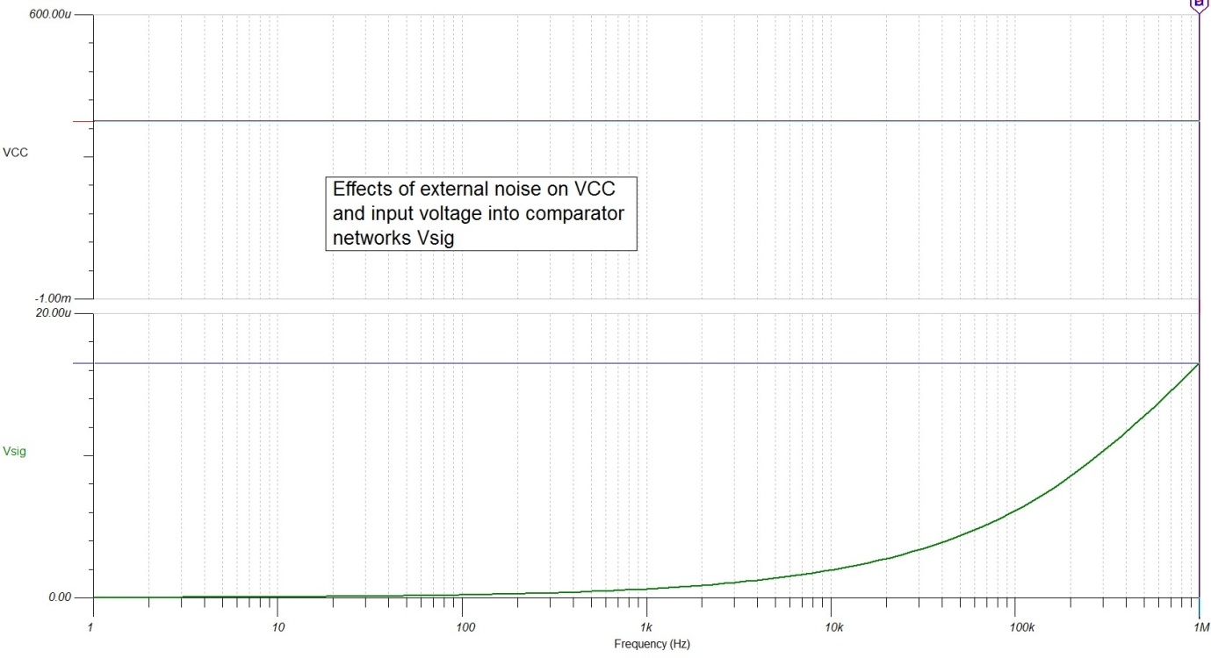

Figure 22.

Figure 23 shows the SNR[5][4] of the circuit considering only its produced noise. A maximum SNR of 330 db is achieved apparent to the input of the comparator circuits. The top curve shows the SNR as seen by the output diodes, which is even larger than that seen by the input of the comparators. This suggests that the circuit is very stable in terms of noise.

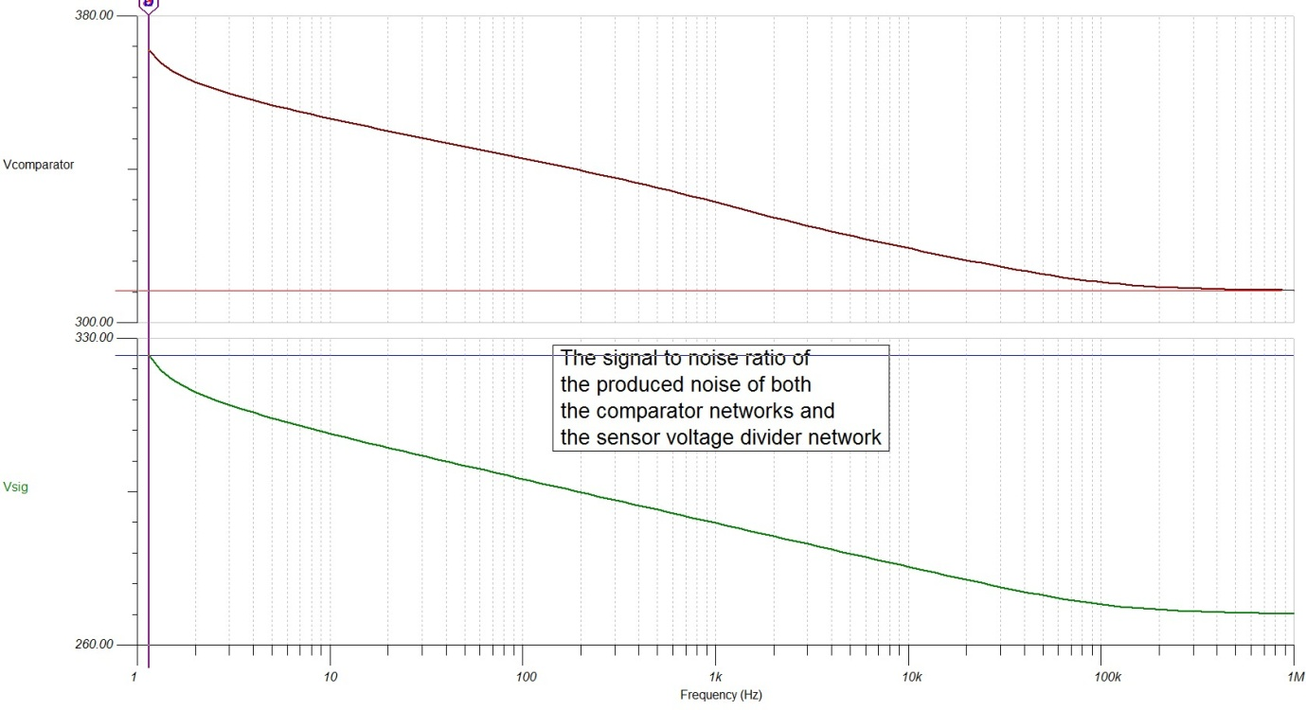

Figure 23.

**6.6 Final circuit**

Figure 24 shows the final circuit design chosen. It includes a 5V voltage regulator, a voltage divider network consisting of 3 10MΩ potentiometers, a timing circuit constructed of a 1MΩ, 1.2MΩ and a 2.2MΩ resistor with a 100uF capacitor, a LM324 comparator operational amplifier and an LED, a sensing circuit which acts as a simple voltage divider using a 22kΩ load resistor and 3 feedback latching comparator networks constructed from a 1N4004 diode, a 10MΩ feedback resistor, a series current limiting resistor for the LED and an LM324 comparator operational amplifier. The reference voltages are



Figure 24.

**7. Conclusion**

The final circuit fulfilled all the criteria except temperature and humidity stability. A careful choice in load resistance helped reduce the effect of temperature on the sensor circuit however there were still fluctuations. The final circuit provides the user with complete reset control and restricts use until the sensor is warmed up, reducing the chance of faulty readings. The circuit is also accurate at identifying the approximate alcohol level in the user’s blood. Noise within the circuit was a bare minimum and a maximum SNR of 330 db was achieved incident on the input of the comparators effectively eliminating the need to consider noise further. The breath alcohol indicator came well under budget at $20.186. Although the temperature and humidity instability could not be reduced the breath alcohol meter met all the required criteria set out including timing, coming under a $25 budget, it can operate between 7V and 9V, gives expected readings for alcohol concentrations and can obtain readings within a normal exhaled breath.

**8. References**

[1] Play-Hookey website. A precision half wave rectifier. Taken from

<http://www.play-hookey.com/analog/half-wave_rectifier.html>

[3] Exploring electrical engineering. Temperature Sensor. Taken from

<http://www.facstaff.bucknell.edu/mastascu/elessonshtml/Sensors/TempR.html>

[4] Basic car audio electronics. Signal to noise ration. Taken from

<http://www.bcae1.com/sig2nois.htm>

[5] Micro-chip technology. NTC thermisters. Taken from

<http://www.microchiptechno.com/ntc_thermistors.php>

[6] Sourceforce.net . taken from

<http://thermistor.sourceforge.net/>

[7] Fackstaff. Diodes. Taken from

<http://www.facstaff.bucknell.edu/mastascu/elessonshtml/Diodes/Diode1.html>

[8] How stuff works. How semiconductors work. Taken from

<http://electronics.howstuffworks.com/diode.htm>

[9] Hyper physics. Voltage divider. Taken from

<http://hyperphysics.phy-astr.gsu.edu/hbase/electric/voldiv.html>